**EXPERIMENT 4: DETERMINING YOUNG’S MODULUS OF A MATERIAL**

Name: Asmito Ghosh

Registration Number: IACS02721

Group: A2

Laboratory Partner: Ankur Saha

Date: 02/09/2024

OBJECTIVE:

* To measure the length, thickness and breadth of the given beam.
* To determine the depression length due to bending at the point where load is attached.
* To calculate the young’s modulus of the material of the beam.

THEORY:

Stress is defined as the restoring force per unit area of a material that arises from externally applied forces, uneven heating, permanent deformation or other deformations.

Mathematically,

Stress = Restoring Force / Area of cross-section

=𝐹𝐴

Strain is the deformation produced in a body in the direction of force applied, per unit initial dimensions of the body. Longitudinal strain is defined as the increase in length per unit initial length of the body when acted upon a specific stress.

Longitudinal Strain = Change in Length / Unit Length

= ΔL / L

Young’s modulus of a body is defined as the ratio of longitudinal stress to longitudinal strain.

Y = Stress/Strain

= FL / AΔL

For a metal beam of length (L), breadth (b), thickness (d), the Young’s Modulus (Y) is given by:

Y = $\frac{gL^{3}}{4bd^{3} }\left(\frac{M}{∆L}\right)$

Where: M = mass on the beam  
 g = acceleration due to gravity

APPARATUS REQUIRED:

* Metal Beam
* Two knife edges for support,
* Weight Hangers and Weights
* Travelling Microscope
* Vernier Calliper.

PROCEDURE:

* First, using a Vernier calliper, the breadth and thickness of the metal beam was measured.
* The metal beam was placed over the two supports at the two ends of the beam.
* The length of the beam was measured and the midpoint was determined.
* The weight hanger was placed at the midpoint of the beam.
* The travelling microscope was adjusted accordingly so that the tip of the weight hanger was clearly visible through the microscope.
* Different masses (M) were placed in the weight hanger, gradually increasing the total mass on the beam and the depression was then measured by accordingly adjusting the microscope.
* The change in depression with respect to the attached mass was recorded.
* The above steps are then repeated by lifting the masses and recording the corresponding change in elevation of the beam.
* The observed data was plotted in a M vs ∆L graph.

RESULTS:

Breadth of Beam:

|  |  |  |  |  |
| --- | --- | --- | --- | --- |
| Sl No. | Main scale reading (cm) | Vernier scale division (cm) | Vernier scale reading (cm) | Total (cm) |
| 1 | 1.90 | 4 | 0.04 | 1.94 |
| 2 | 1.90 | 3 | 0.03 | 1.93 |
| 3 | 1.90 | 4 | 0.04 | 1.94 |

Width of Beam:

|  |  |  |  |
| --- | --- | --- | --- |
| Sl No. | Linear scale reading (cm) | Circular scale reading (cm) | Total (cm) |
| 1 | 0.4 | 27 | 0.427 |
| 2 | 0.4 | 28 | 0.428 |
| 3 | 0.4 | 30 | 0.430 |

Change in Beam Elevation:

|  |  |  |  |  |  |  |  |  |  |
| --- | --- | --- | --- | --- | --- | --- | --- | --- | --- |
| Sl No. | Mass (kg) | Loading | | | Unloading | | | Average reading (cm) | Elevation  (cm) |
|  |  | MSR  (cm) | VSR * VC (cm) | TR  (cm) | MSR  (cm) | VSR * VC (cm) | TR  (cm) |  |  |
| 1 | W | 0.0 | 0.00 | 0.00 | 0.0 | 0.00 | 0.00 | 0.00 | 0.00 |
| 2 | W + 0.452 | 0.4 | 0.02 | 0.42 | 0.4 | 0.04 | 0.44 | 0.43 | 0.43 |
| 3 | W + 0.917 | 1.0 | 0.00 | 1.00 | 1.0 | 0.02 | 1.02 | 1.01 | 1.01 |
| 4 | W + 1.394 | 1.5 | 0.06 | 1.56 | 1.5 | 0.06 | 1.56 | 1.56 | 1.56 |

GRAPHS AND CALCULATIONS:

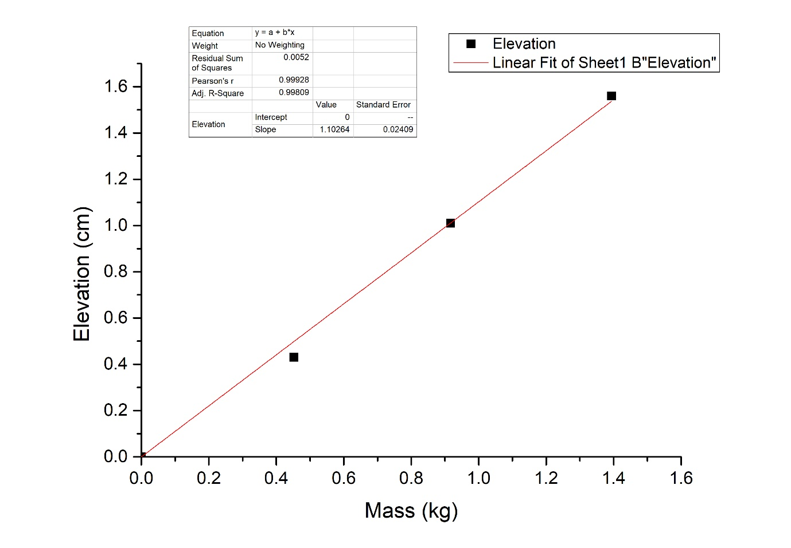

As per Recorded Observation:

Slope = l/M

= 1.10264 cm/kg

= 0.0110264 m/kg

So, Young’s modulus = Y = $\frac{gL^3}{4bd^3}$ ($\frac{M}{l}$)

⇒ Y = 1.37*1011 N/m2

ERROR ANALYSIS:

Maximum percentage error ($\frac{dY}{Y}$) = (3 $\frac{dL}{L}$ + $\frac{db}{b}$ + $3\frac{d(d)}{d}$ + $\frac{dM}{M}$ + $\frac{dl}{l}$) * 100%

1st case: (M = 0.452kg, l = 0.0043 cm)

Error = ($\frac{dY}{Y}$) = 3 $\frac{0.001}{0.979}$ + $\frac{0.0001}{0.0194}$ + $3\frac{0.00001}{0.00427}$ + $\frac{0.001}{0.452}$ + $\frac{0.0002}{0.0043}$)*100 %

= 6.40 %

2nd case: (M = 0.917kg, l = 0.0101 cm)

Error = ($\frac{dY}{Y}$) = 3 $\frac{0.001}{0.979}$ + $\frac{0.0001}{0.0194}$ + $3\frac{0.00001}{0.00427}$ + $\frac{0.001}{0.917}$ + $\frac{0.0002}{0.0101}$)*100 %

= 3.61 %

3rd case: (M = 1.394kg, l = 0.0156 cm)

Error = ($\frac{dY}{Y}$) = 3 $\frac{0.001}{0.979}$ + $\frac{0.0001}{0.0194}$ + $3\frac{0.00001}{0.00427}$ + $\frac{0.001}{1.394}$ + $\frac{0.0002}{0.0156}$)*100 %

= 2.88%

Average error = 4.30%

REMARKS:

Thus, we find the Young’s Modulus of the metallic beam by comparing its change in elevation when mass is added to it.